**Learn in Community**

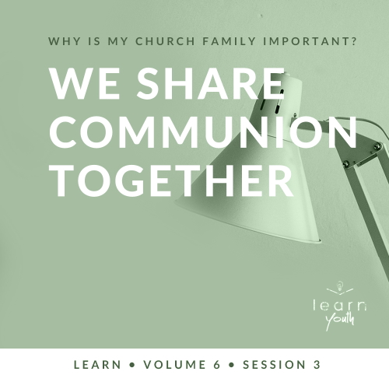

Small Group Study



**Volume Overview**

**Why is my church family important?**

“For where two or three gather together as my followers, I am there among them.” ([Matthew 18:20](https://ref.ly/logosref/Bible.Mt18.20))

*As Christians, we follow Jesus, but we were never meant to follow Jesus by ourself. God gave us a spiritual family to walk with through the highs and lows of life. That family is called the Church! Why is the Church important? What role does the Church play in our life, and what role does each of us play in the Church? This volume will explore questions like these as we investigate what the Bible says about the Church*.

|  |
| --- |
| ***You Will Need***  *• Enough dessert (e.g., pie, cake, or brownies) to share with the entire group*  *• Plates, plastic forks, and napkins for the group*  *• Traditional Communion elements (bread or crackers and grape juice)*  ***Getting Ready***  • *First time leading* Learn *for Youth? Look here for the* [Facilitator Guide](https://0b769b0ed3569ef9d18b-f88d8272f61086866d50d048b43ef630.ssl.cf2.rackcdn.com/sites/biblengagementproject/Listen_Facilitator_Guide.pdf). |

*To access session content and videos from a computer, visit:*

[*BibleEngagementProject.com/downloads*](https://bibleengagementproject.com/downloads)

**Engage**

**Welcome**

*Take this time to welcome everyone, introduce new students, learn names, and thank everyone for coming*.

|  |
| --- |
| **QUESTION**  If you could have a five hundred dollar gift card to any restaurant in the world, where would you choose to go? |

**Opening Prayer**

*Prayer thoughts: Take prayer requests from your group, and devote time to pray over each need during your group prayer. Encourage students to also pray for their schools and church*.

**Introduction**

Today we’re going to look at a very special meal that Jesus had with His closest followers. In fact, it was so special that Christians still celebrate part of this very meal today. It’s what we call Communion. Let’s talk about what Communion is and why it’s so important.

**Group Activity**

**Snack Time**

|  |
| --- |
| ***You Will Need***  *• Enough dessert (e.g., pie, cake, or brownies) to share with the entire group*  *• Plates, plastic forks, and napkins for the group*  *No prep is needed for this activity.* |

We’re going to kick off our discussion today in the easiest way possible! We’re going to enjoy some scrumptious dessert together. As we eat, let’s share what’s going on in our lives and connect as we eat just as Jesus and His disciples did.

• *After distributing the dessert, try to facilitate intentional conversations to help your group grow closer in community*.

|  |
| --- |
| **QUESTION**  How often do you sit around a table to eat with your family or your friends? |

|  |
| --- |
| **QUESTION**  Who were the last two people outside of your family you shared a meal with? |

* *Continue to ask about families, school routines, hobbies, and anything else that could help build relationships. Invite students to ask questions, too*.

Usually, we sit down for meals with the people we love or like a lot. Think about it. You’re a lot more likely to eat a meal with a close friend than you are a total stranger. Some of our most meaningful moments can happen when we’re gathered around the table.

It was no different for Jesus. Today’s Bible story takes place around a table, but this was no ordinary meal. Jesus and His disciples had gathered for Passover—a special celebration the Jews had every year. Jesus’ disciples didn’t know it yet, but this would be their last meal with Jesus before His death. While they were eating, Jesus taught His disciples about how that meal connected with the giving of His life. As you’re finishing up your treat, let’s watch today’s video.

**Watch**

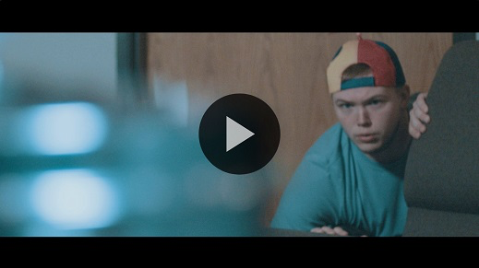

**Consider What the Bible Says**

*Ensure each student has access to a Bible, preferably the same version*.

|  |
| --- |
| **QUESTION**  How many of you have taken Communion before? |

|  |
| --- |
| **QUESTION**  What have you been taught about Communion and why it’s important? |

Communion isn’t something that we just came up with. Christians have been eating bread and drinking juice from grapes together since the beginning of the Church around two thousand years ago. This special activity helps us remember Jesus’ death and is a symbol of our connection with Him. This practice began because of a meal Jesus shared with His disciples the night before His death. Let’s take a look at that night and see what we can learn.

**Through Communion, We Remember Jesus’ Sacrifice**

Read [Matthew 26:17–19](https://ref.ly/logosref/Bible.Mt26.17-19), [26–30](https://ref.ly/logosref/Bible.Mt26.26-30).

|  |
| --- |
| **QUESTION**  What did Jesus say the bread represents? |

|  |
| --- |
| **QUESTION**  What did His blood confirm? |

|  |
| --- |
| **QUESTION**  How do you think the disciples felt when Jesus told them that what they were eating represented His broken body and shed blood? |

They might have been surprised and confused that Jesus interrupted the meal, but it wasn’t the first time Jesus did or said something unusual. Then, just a few hours later, what Jesus shared came true. Scripture tells us Jesus’ body was broken, and His blood was shed for us. He did this on the Cross for you and me. Let’s take a moment to reflect on Jesus’ sacrifice.

|  |
| --- |
| **QUESTION**  How does it make you feel knowing Jesus’ body was broken and blood shed for your forgiveness? |

Jesus used the bread and the cup as a visual to illustrate the sacrifice that He would make. In the same way, taking Communion together reminds us that Jesus’ sacrifice paid for our sins, too ([1 Corinthians 11:24](https://ref.ly/logosref/Bible.1Co11.24)). Imagine the disciples taking Communion together for the first time after Jesus’ death and resurrection. No doubt what Jesus had said to them that night now made a lot more sense.

|  |
| --- |
| **QUESTION**  How do you think the disciples felt taking Communion together after Jesus had died and was resurrected? |

**Did You Know?**

|  |
| --- |
| The meal that Jesus and His disciples shared together would have been the Passover Seder. This meal was not just a simple dinner, but instead, a large feast that was looked forward to every year. To most Jews, this would have been one of the most important nights of the year as they remembered God’s deliverance of their ancestors from enslavement in Egypt. |

**Through Communion, We Are United with Jesus and His People**

Read [1 Corinthians 10:16–17](https://ref.ly/logosref/Bible.1Co10.16-17).

Communion is something that we usually take together, not on our own. Doing so reminds us that we are united with Christ. We share in His sufferings and in His glory ([Romans 8:17](https://ref.ly/logosref/Bible.Ro8.17)). And because we’re all united with Christ, we’re one body with one another—one Church. So, it’s an opportunity for us as Christians to grow closer as we all are united and focused on the awesome work our Savior did.

|  |
| --- |
| **QUESTION**  What do you think a united Church looks like? |

|  |
| --- |
| **QUESTION**  What are some examples of how people outside the Church are divided today? |

|  |
| --- |
| **QUESTION**  How could our unity as the Church serve as a way to share our faith in such a divided world? |

Communion is meant to be a powerful reminder of what Jesus did for us. It’s a big deal! And because it’s such a big deal, Communion is something we should take very seriously.

**Before Communion, We Examine Our Life**

Read [1 Corinthians 11:23–31](https://ref.ly/logosref/Bible.1Co11.23-31).

Just before this instruction on Communion, Paul told his readers that what he’s sharing came from Jesus himself. That should add a lot of weight to these instructions for anyone who calls themselves a follower of Jesus. They let us know that we should think about what’s right or wrong in our own life before we take Communion.

|  |
| --- |
| **QUESTION**  Why do you think we need to examine our life before we take Communion? |

|  |
| --- |
| **QUESTION**  How should we respond if we find areas that are sinful or not pleasing to God? |

The last few verses reveal a surprising outcome of taking Communion. There can be real consequences to faking being a believer just to take Communion. We need to make sure our heart and attitudes are in the right place when we take this special meal. This is why many churches give time for people to ask for God’s forgiveness and make things right before taking the bread and juice. It’s more than a ceremony, and we have to approach it with the respect that any command directly from Jesus deserves.

**Reflect**

**We Celebrate Communion Together**

Every Christian is unique. We have different backgrounds, ethnicities, abilities, and personalities. But we all have at least one spiritual thing in common—we’re saved and forgiven because of Jesus’ sacrifice! Communion reminds us of that. Every time we take the bread and the cup together, we remember what Jesus did for us until He comes again one day.

**Listen to God**

Let’s pause and listen to what God might want to say to us about what we have read and shared. Answering the following questions is completely voluntary. These questions are meant to serve as a conversation between you and God. However, you may want to share your response with the group, but no one should feel obligated.

• *Optional: Pause for a few moments of silent reflection before asking students if they want to share*.

Communion reminds us of Jesus’ sacrifice and His death on the Cross for the forgiveness of our sins. Even though Jesus died for our sins, sometimes we struggle to let the bad things we used to do die with our old life.

|  |
| --- |
| **QUESTION**  How have you experienced Jesus’ forgiveness in your life? Even if you’re saved, are there things you need to ask Him to forgive you for? |

|  |
| --- |
| **QUESTION**  Do you feel connected to other Christians? What’s keeping you from being closer to those you should be united with in Jesus? |

**Activate**

Today, we have an opportunity to practice what we’ve just talked about! Let’s close out our time together by taking Communion and remembering all that Jesus has done for us. Before doing so, let’s take time to examine our own heart and life. For those who are followers of Jesus, consider if you have any sin or habit that you need to confess to the Lord. Take a moment and ask the Lord for forgiveness. Jesus is ready to forgive each of us.

• *Give students time to reflect silently*.

|  |
| --- |
| **Salvation Opportunity**  *Include this if you think there may be some in the group who do not have a personal relationship with Jesus.*  Communion is something believers share, so I want to invite anyone who doesn’t know Jesus to surrender their life to Him now. Jesus’ sacrifice made a way for us to experience forgiveness for our sins and have a relationship with God himself. We can’t make our way to heaven on our own abilities. But Jesus paid the price so that we can! All He asks is that we believe in Him ([John 3:16](https://ref.ly/logosref/Bible.Jn3.16)) by trusting Him with our life.  **Is there anyone here that we can pray for who doesn’t have a relationship with Jesus or wants to renew their relationship with Him?**  *Take a moment to acknowledge those who respond, and thank them for their desire to make things right between themselves and God. Pray with them as we close in prayer or after the group time is over. Following group time, talk more about where they are in their walk with God and how you might be able to help.* |

**Communion**

• *Close out time by taking Communion together as a group*.

• *Distribute the bread and juice. Consider reading* [*Matthew 26:26–28*](https://ref.ly/logosref/Bible.Mt26.26-28) *together*.

|  |
| --- |
| **QUESTION**  Would anyone like to share why you’re thankful for Jesus as we take Communion? |

**Prayer**

Sacrificial God, we remember Your love and Your sacrifice for us! Thank You for doing what we could not do by sending Jesus to die for the forgiveness of our sins. Help us to always remember what He did for us. Help Your Church to be unified in a divided world. In Jesus’ name we pray. Amen.

**Conclusion**

As followers of Jesus, we celebrate Communion together as a way of remembering what Jesus has done for us. We don’t take Communion lightheartedly, but we examine our heart and honor God with our actions.

This week, there are five personal devotions to help you stay connected to God and His Word. Don’t forget to jump in and stay engaged with those as you go through your week. I can’t wait to see you next time!